**BASICS & CRUD OPERATIONS**

**Basics:**

* In mongo-db we just have to configure our cluster. No further configuration is required.
* The databases and the collections are created on the fly when the first transaction (CRUD) operation takes place on them.
* Since Mongodb is schema-less any kind of data can be stored in the documents.

**Architecture:**

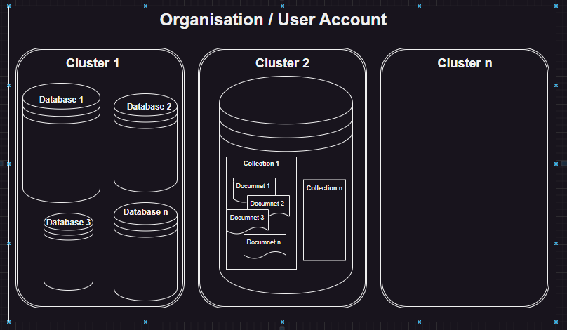

* **Organization / User Account :** An account on the mongodb created by the user to get access to the mongodb database.
* **Cluster :** An organization can have multiple cluster. A cluster can be imagined as a container that holds our databases.
* **Database:** An Cluster can have multiple databases. A database can be imagined as a container that holds multiple collections.
* **Collection:** An database can have multiple collections. A collection can be imagined as a container that holds multiple documents.
* **Document:** An collection can have multiple documents. A documents is the single entry that we store in the collection. It is the lowest entity of the database.

**The use keyword or useDb method:**

* In mongodb shell the **use** keyword is used to switch between databases, and create a new database if not exists.
* In mongodb nodejs driver **useDb(<dbname>)**  method is used to switch between databases or create a new database if not exists.

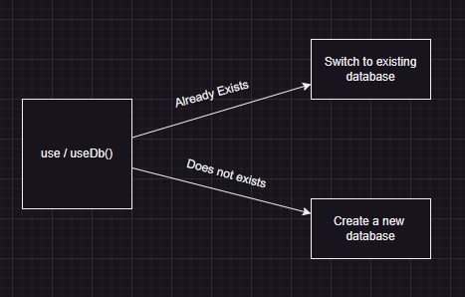

**Database Methods:**

* **db.dropDatabase() :** This method is used to drop the current working database. It will clear all the collections and delete database.
* **Db.stats():** This method is used to get detailed information about the database example given below:

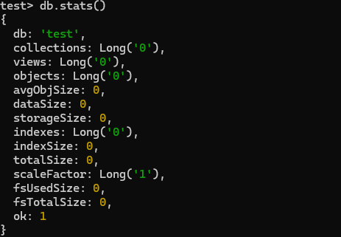

**CRUD OPERATIONS (collection methods):**

* **(C => Create):**  These operations are used to create a new entry in the database collection.
  + insertOne(data, options)
  + insertMany(data, options)

**Note:**

* + - **The _id or mongodb object id is automatically generated for each documents by mongodb server on every create operation.**
* **(R => Read):**  These operations are used to read the data from the database collection.
  + find(filter, options)

**Note:**

* + - **The find method returns the cursor to the documents (only 20 documents at a time). [e.g. Try running in mongodb shell or see how many documents mongodb compass shows at once.]**
    - **To enforce the method to return the entire data use .toArray() or .forEach() method following .find().**
  + findOne(filter, options)
* **(U => Update):**  These operations are used to update the data in the database collection.
  + updateOne(filter, data, options)
  + updateMany(filter, data, options)
* **(D => Delete):**  These operations are used to delete the data from the database collection.
  + deleteOne(filter, options)
  + deleteMany(filter, options)